S

ubject

Name:

**S**

**o**

**urce**

**C**

**o**

**de**

**M**

**a**

**n**

**a**

**gement**

S

ubject

Co

de:

**2**

**2**

**CS003**

Session:

**2**

**022-23**

Departm

e

nt:

**DCSE**

**S**

**ubmitt**

**e**

**d**

**B**

**y:**

Uday Kalra

2210990918

G

3

0

–

A

**Submitt**

**e**

**d**

**To:**

Mr. Sharad Chauhan

Associate Professor

DCSE



Page - 1

|  |  |  |  |  |  |  |  |  |  |  |  |  |  |  |  |  |  |  |  |  |  |
| --- | --- | --- | --- | --- | --- | --- | --- | --- | --- | --- | --- | --- | --- | --- | --- | --- | --- | --- | --- | --- | --- |
| **List of Programs**   |  |  |  | | --- | --- | --- | | **S. No** | **Program Title** | **Page No.** | |  | **TASK 1.1** |  | | 1 | Setting up OS git Client. | 3 - 5 | | 2 | Setting up GitHub Account. | 6-7 | | 3 | Generate log. | 8-10 | | 4 | Create and visualize branches. | 11-13 | | 5 | Git life cycle description. | 14-15 |   Page - 2 |

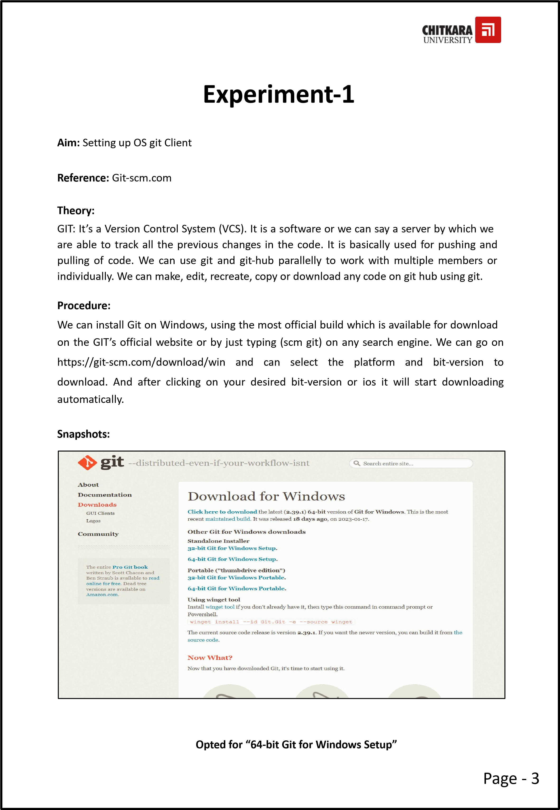



**G**

**it**

**a**

**n**

**d**

**its**

**f**

**i**

**les**

**i**

**n**

**d**

**o**

**w**

**nl**

**oads**

**G**

**IT**

**S**

**e**

**t**

**up**

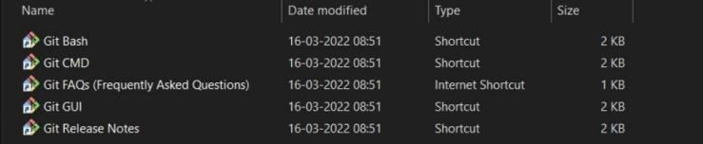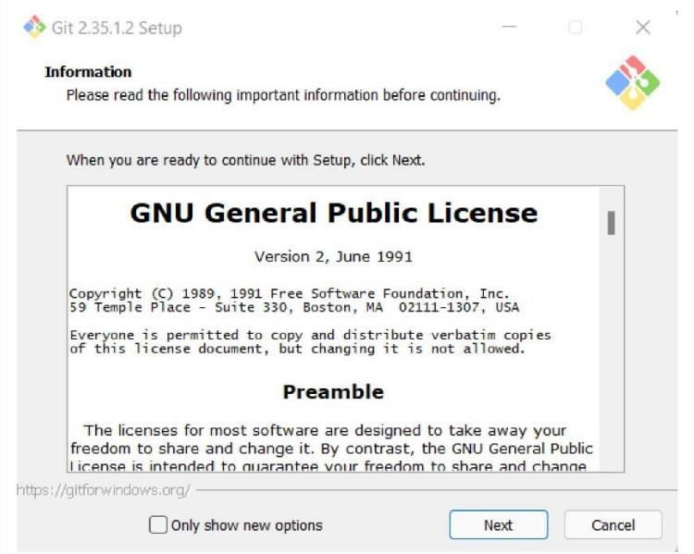

Page - 4



**G**

**it**

**In**

**s**

**tal**

**l**

**a**

**t**

**ion**

**G**

**it**

**B**

**a**

**sh**

**La**

**un**

**c**

**h**

**e**

**d**

**R**

**esult**

**:**

We

h

ave

s

u

cc

essf

ull

y

s

e

t

u

p

o

u

r

g

i

t

c

li

e

n

t

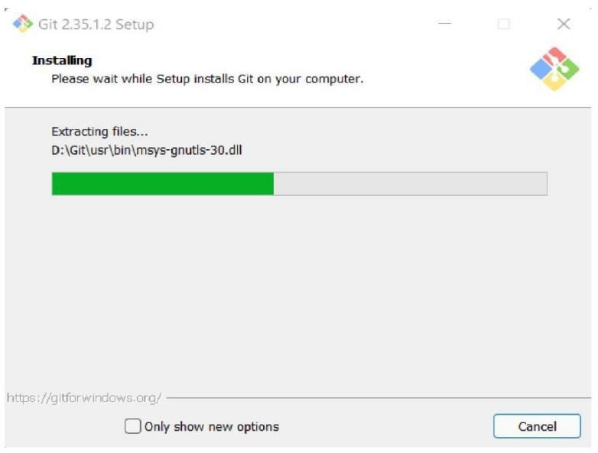

Page - 5

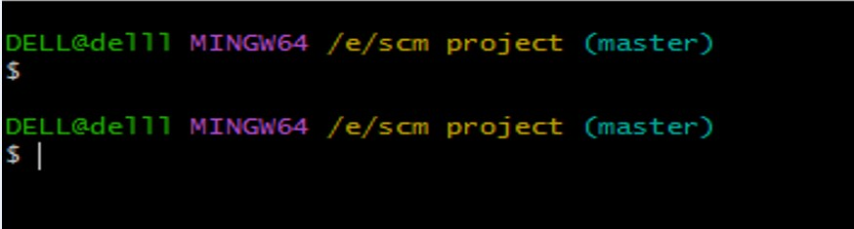

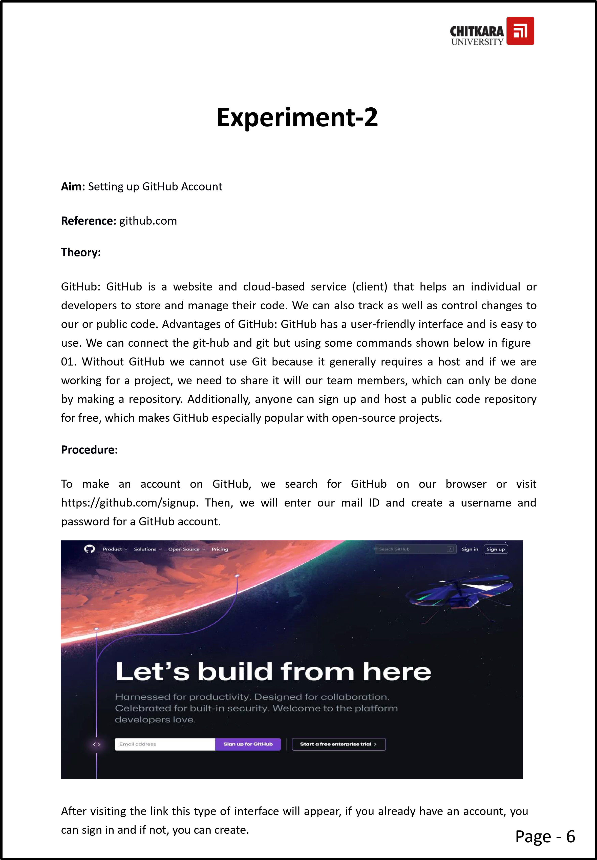



**G**

**itH**

**u**

**b**

**Login**

**G**

**itH**

**u**

**b**

**I**

**n**

**terf**

**a**

**ce**

**R**

**esult:**

W

e

have

s

u

cces

s

full

y

cre

a

t

e

d

o

u

r

G

i

tH

ub

ac

c

o

u

n

t

.

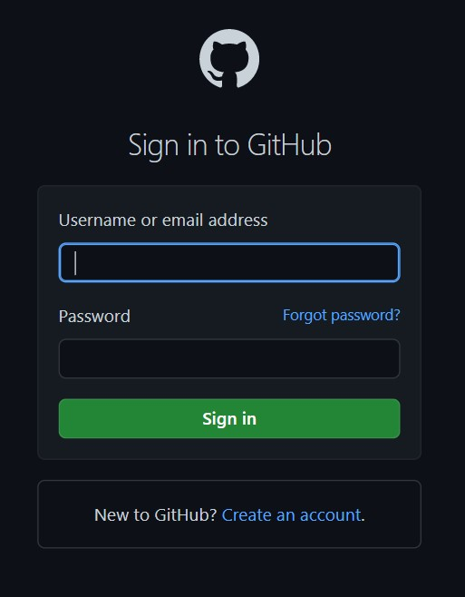

Page - 7

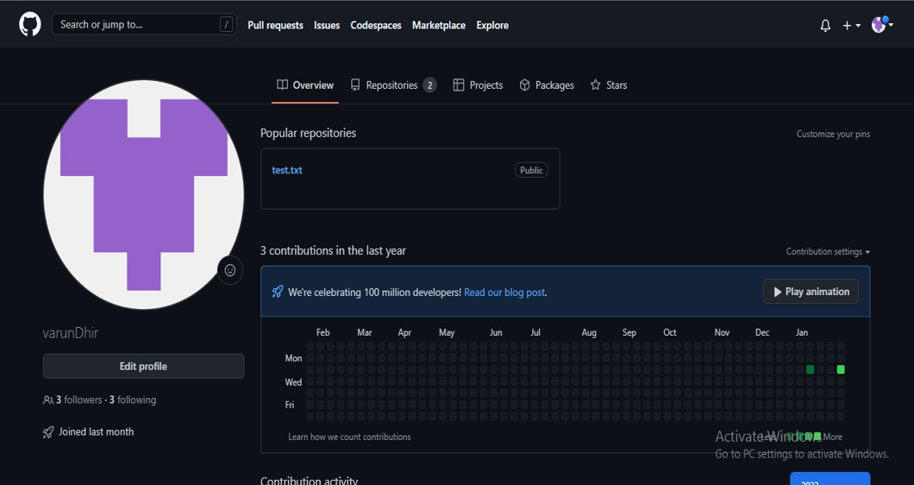

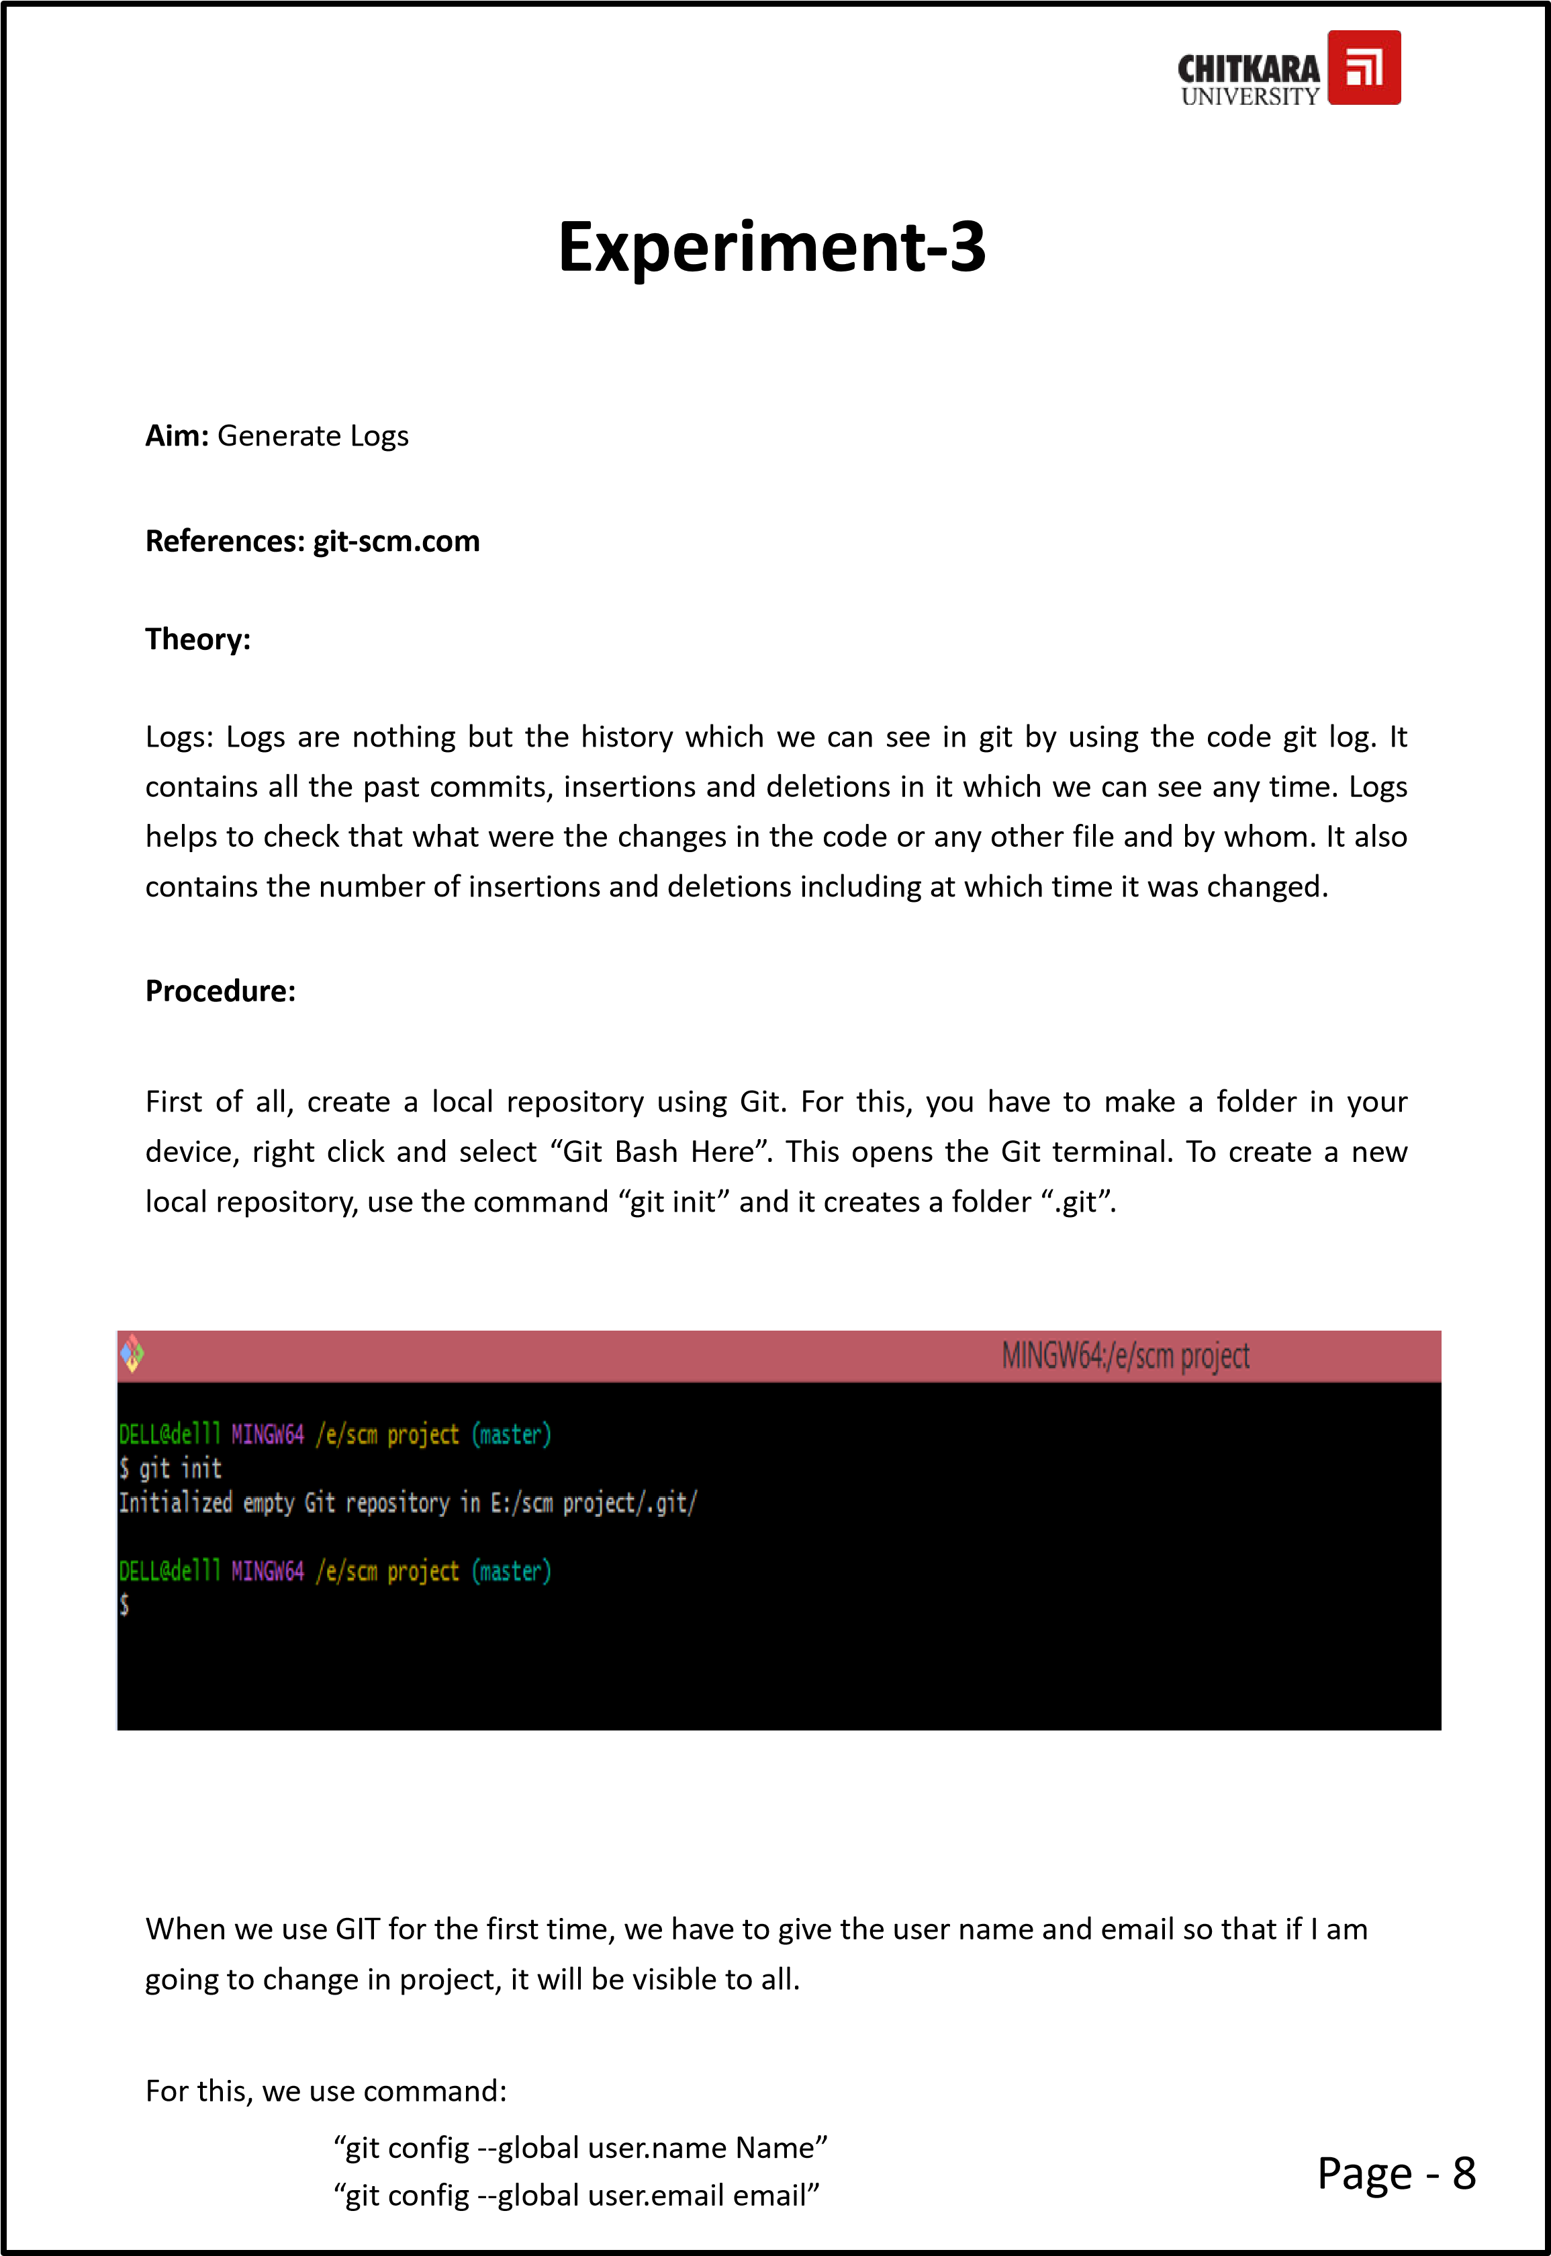



F

o

r

ver

i

fy

i

n

g

t

he

u

se

r’s

n

ame

a

nd

ema

il

,

w

e

u

s

e

:

“gi

t

c

onf

i

g

--

gl

o

bal

u

ser.

nam

e

”

“gi

t

c

onf

i

g

--

gl

o

bal

u

ser.

e

mai

l

”

**1.**

F

i

rst

create

a

te

x

t

fi

l

e

a

n

d

t

h

en

a

d

d

t

h

e

t

ext

fi

l

e

t

o

t

h

e

f

o

l

d

er

w

i

t

h

g

i

t

**2.**

Co

m

mi

t

t

he

a

b

ov

e

te

x

t

fi

l

e

**3.**

Use

gi

t

l

o

g

c

o

m

m

a

n

d

t

o

check

t

h

e

l

ogs

Page - 9

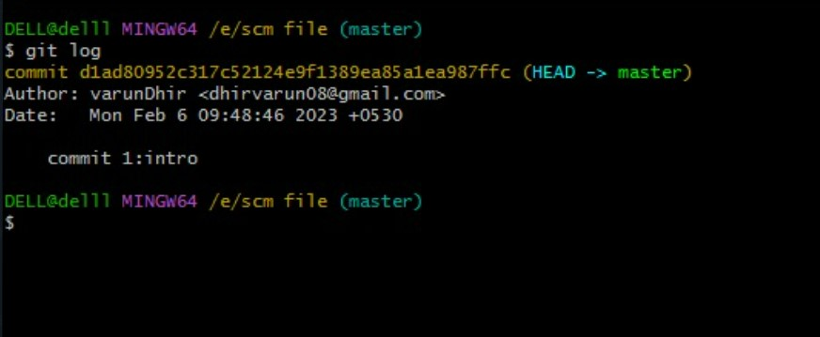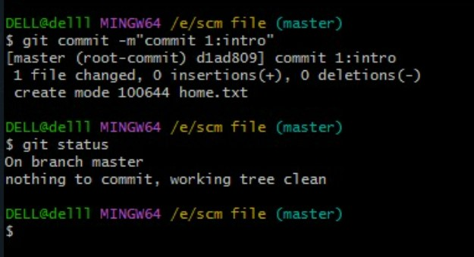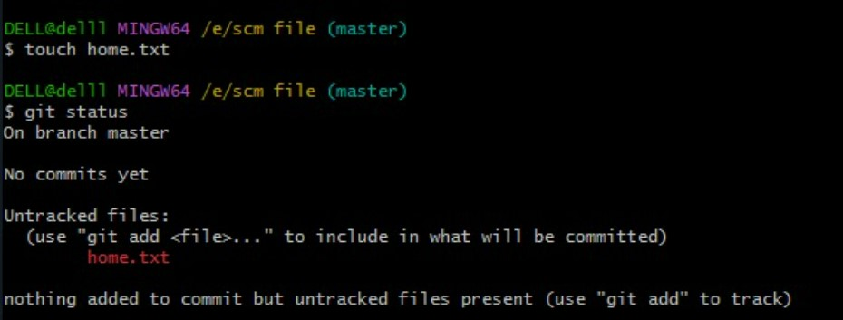

|  |
| --- |
| The git log command displays a record of the commits in a Git repository. By default, the git log command displays a commit hash, the commit message and other commit metadata.  **Some Important Commands :-**   * **$ git init** * **$ git status** * **$ git config –global user.email “** **”** ❖ **$ git config –global user.name “** **”** * **$ git config user.email** * **$ git config user.name** * **$ ls -la** * **$ git add .txt** * **$ git commit -m “** **”** * **$ git log** * **$ git ls** * **$ git ls -lart** * **$ git clear** * **$ git rm -rf .git**   **Result:** We have successfully generated logs.  Page - 10 |

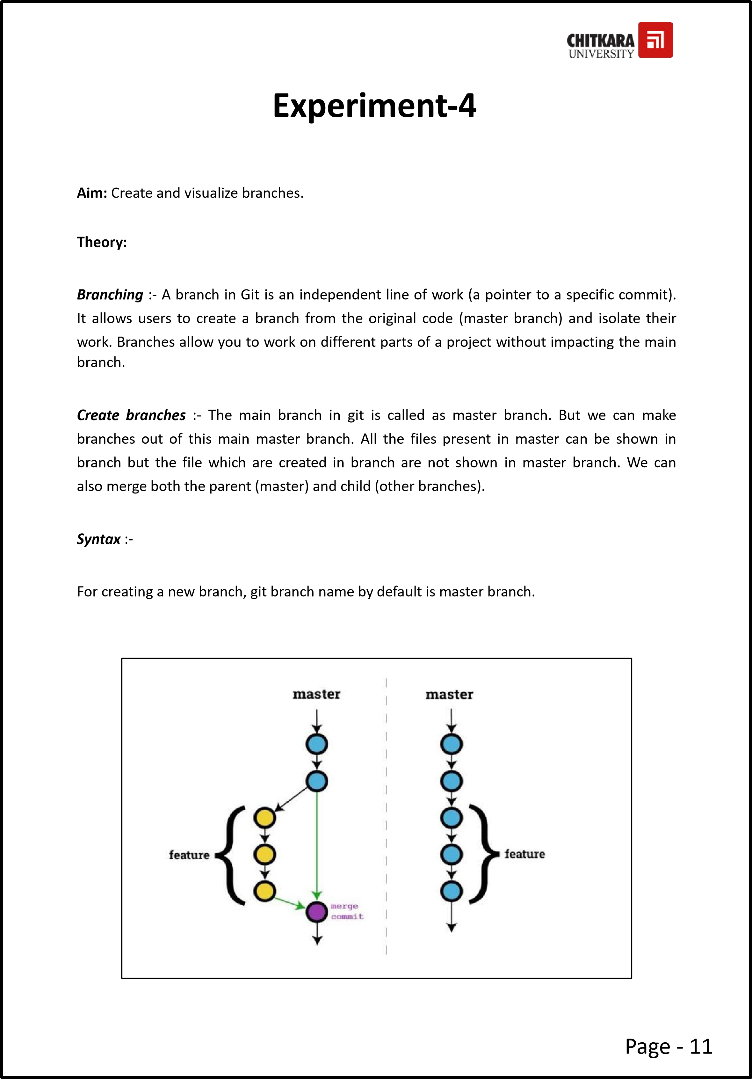



**Sna**

**p**

**s**

**h**

**ots**

**:-**

**De**

**f**

**a**

**ult**

**b**

**r**

**a**

**n**

**c**

**h**

**is**

**m**

**a**

**ste**

**r**

**b**

**r**

**a**

**n**

**c**

**h**

**Ad**

**d**

**in**

**g**

**a**

**nd**

**s**

**wi**

**tc**

**h**

**in**

**g**

**t**

**o**

**a**

**n**

**e**

**w**

**b**

**r**

**a**

**n**

**c**

**h**

**Sw**

**itc**

**h**

**in**

**g**

**b**

**a**

**c**

**k**

**to**

**M**

**AS**

**T**

**ER**

**b**

**r**

**a**

**n**

**c**

**h**

Page - 12

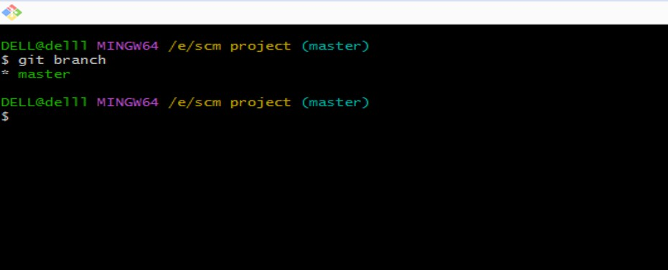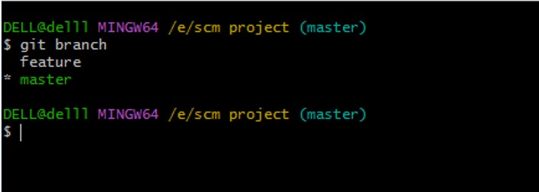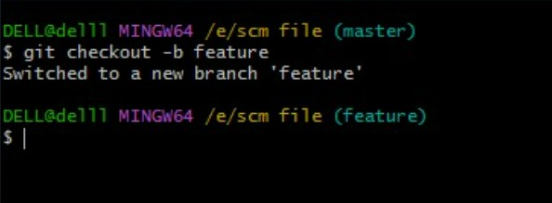

**C**

**h**

**eck**

**i**

**n**

**g**

**C**

**o**

**mmits**

**Note**

**:-**

**1.**

**Cha**

**nges**

**a**

**t**

**New**

**Br**

**an**

**c**

**h**

**w**

**o**

**n**

**’**

**t**

**be**

**vi**

**s**

**i**

**bl**

**e**

**in**

**M**

**ASTER**

**b**

**ra**

**n**

**ch**

**Res**

**u**

**l**

**t**

**:**

**-**

We

h

ave

su

cc

essf

u

lly

c

reat

e

d

a

n

d

vis

u

alized

log

s

.

Page - 13

